1. Draw an ER diagram for the pharmacy database.

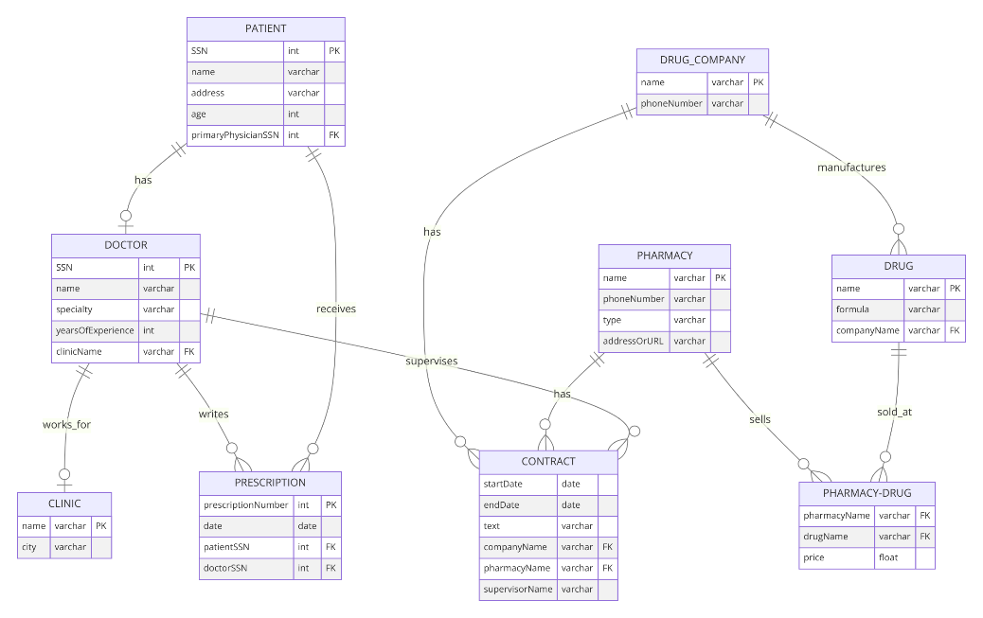

1. How would your design change if each drug must be sold at a fixed price by all pharmacies?

* 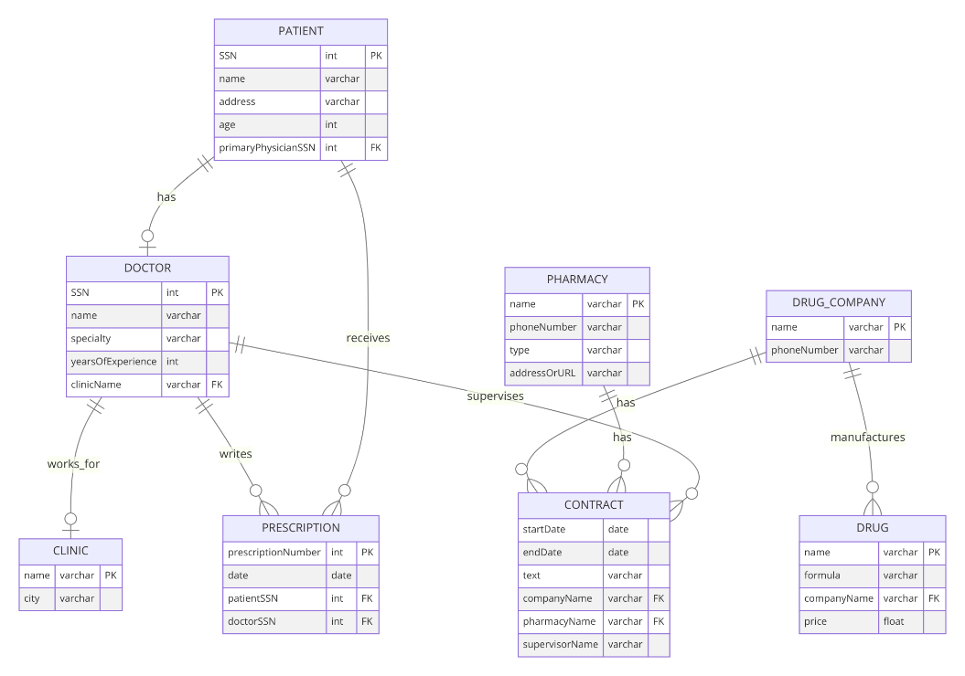PHARMACY no longer has a direct relationship to the DRUG entity through PHARMACY-DRUG associative entity
* DRUG no includes the price attribute directly